Flexibility and the FITT Principal

This week we are going to concentrate on flexibility in our fitness plan.

Flexibility is the ability to move joints through their full range of motion. The sit and-
reach test is a good measure of flexibility of the lower back and the backs of the
upper legs (hamstrings). A person’s flexibility is usually expressed in how far a joint can be moved or the degrees through which a joint can be moved.
Warm-up/Cool-down
Students should always warm-up before beginning to exercise to prevent injury. An effective warm-up increases the muscle temperature. A warm-up should consist of light physical activity for 5 to 10 minutes of exercise, such as walking, slow jogging, knee lifts, arm circles, or trunk rotations. Low-intensity movements that simulate movements to be used in the activity can also be included in the warm-up. This increase in temperature improves circulation to the working muscles, increases muscle elasticity, and prepares tendons and ligaments for activity. The warmup should be long enough for students to begin to sweat. You should always do some light aerobic exercise (exercise which increases the heart rate and raises the breathing rate) before starting to stretch and work on flexibility.
Remember….. warm muscles are flexible muscles

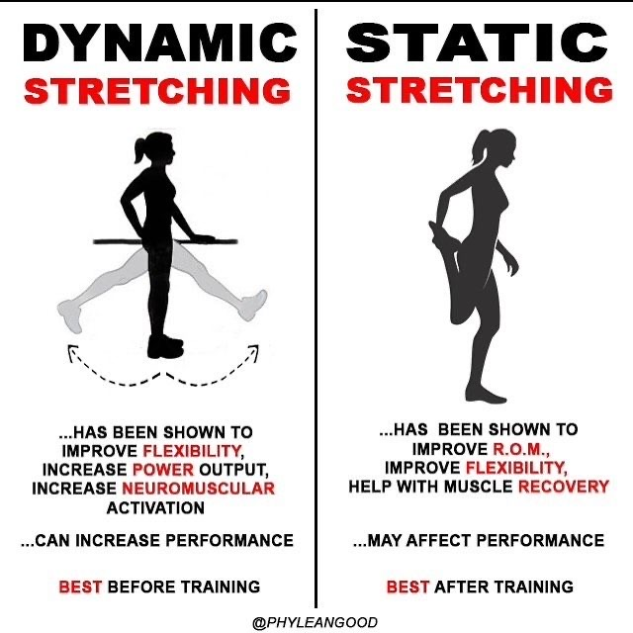
Dynamic Stretching
This is stretching while moving. The latest research says dynamic stretching should be used in the warm-up after the light aerobic exercise.

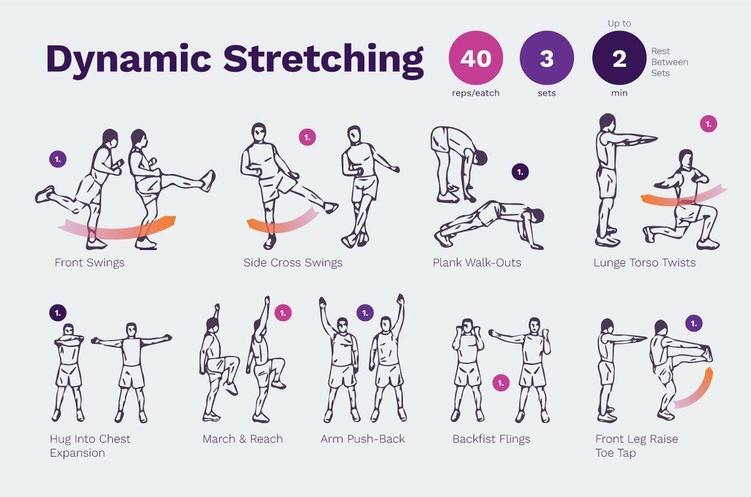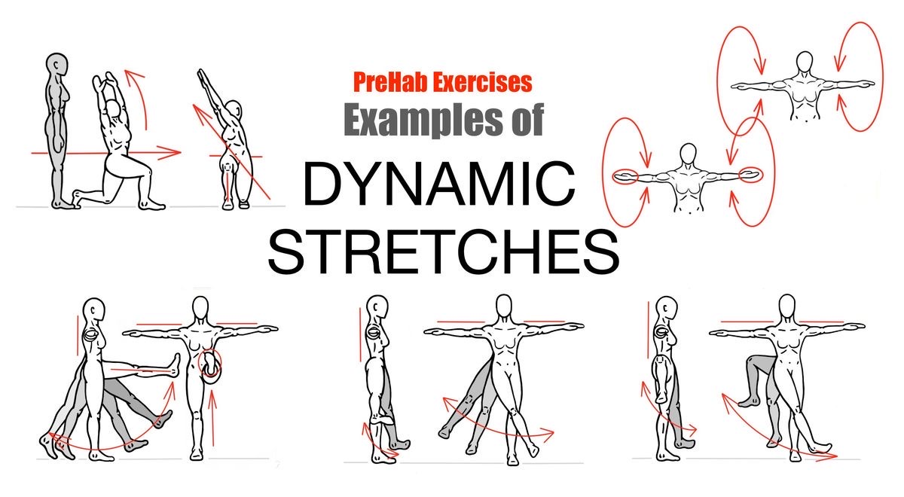
Static Stretching
This is stationary kind of stretching that should be included in the cool down or the end of the workout. You should stretch until you feel a slight pull on the muscle(s) and hold that position for 15 to 30 seconds. At the end of every workout, perform 5 to 10 minutes of static stretching
exercises.
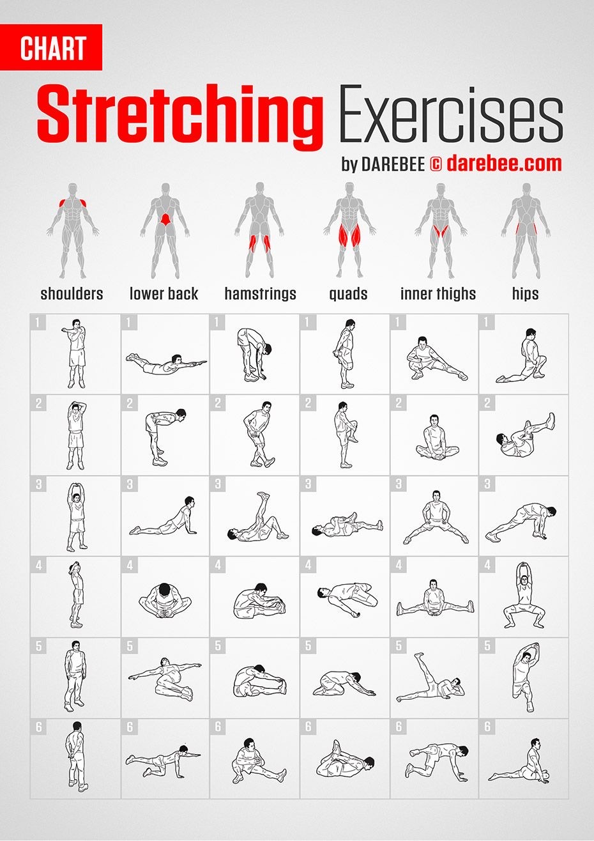
This week we want you to focus on Flexibility. Fill in the boxes under Flexibility using the chart “A Balanced Fitness Program: What to consider”. See my example for help. We will plan a program for each component every week. Continue to fill in your exercise log.
A Balanced Fitness Program: What to consider
F.I.T.T | Cardiovascular  Endurance | Flexibility | Muscular Endurance | Muscular  Strength | Body  Composition
F  Frequency | 3-5 days per week | Do every day  Should be a part of every warmup and cool down | 3-4 times per week  Vary muscle groups | 3 times per week | 5 -7 days per week
I  Intensity | Stay in your target zone  Moderate- Vigorous  Begin in lower limit and increase gradually | Static stretches held for 15-30 sec  Slow and controlled | 15 or more reps/1-3 sets  Less than 60% of predicted Maximum Rep | 8-10 Reps/1-3 Sets | Combination of intensities
T  Type of  activity | Running, cycling, swimming, walking etc-  Continuous activities that use large muscles | Static stretches  dynamic stretches | Medicine balls  Resistance bands  Free weights  Body Weight | Medicine balls  Resistance bands  Free weights  Body Weight | Cardiovascular  Anaerobic  Weight Training
T  Time | At least 30 min of continuous exercise | About 10 minutes | About 30 Minutes | About 15 minutes | Depends on intensity

Plan your flexibility routine using the information on static and dynamic stretches above and the FITT principal. Make sure you warm up first. List your stretches below in your student activity sheet. You can find and list your own stretches that you know or search for more on internet.
Good luck, stay healthy and Raider Strong!

Student Activity Sheet Name:
Date:
Planning Your Fitness Program
Use the chart below to outline your fitness program.

F.I.T.T | Cardiovascular  Endurance | Flexibility | Muscular Endurance | Muscular  Strength | Body  Composition
F  Frequency | 5 times per week  Run – Tues, Thurs, Sat, Sunday  Hike- Friday | Should be a part of every warmup and cool down  Everyday
I  Intensity | Target Zone  120-144 b/min  Run  Vigorous intensity  Moderate  Hike | Static stretches held for 15-30 sec  Slow and controlled
T  Type of  activity | Running  Walking  Hiking | List your static stretches  List your Dynamic Stretches
T  Time | Running- 40-120 min  Walking- 30 min  Hiking- 60 min | Do  About 10 min a day  Before and after workout

